Arab Open University

Language Studies Deanship
English Language Unit
EL112 STMA

Student’s Name | Student’s ID

Please read carefully before you proceed to the questions:
- This exam is out of 100points.
- Students will refer back to their course books wheneverindicated in the questions.
- Students are required to answer all questions over the space of a week.
- Exam date is Thursday, April 30
- Exam submission date isThursday, May 7
- No email submission is allowed under any circumstances.
- Submission is only through LMS.

Section | Section Maximum Points | Earned Points
Reading Comprehension | 20
Grammar | 30
Vocabulary | 20
Writing & Research | 30
Student’s Total Points

- Reading Comprehension (20 Points)
Read the following article and then answer the questions that follow:
- Without question, the most important positive action you can take to prevent illness and disease is exercise. Exercise prevents a long list of diseases that can cause chronic or severe illness, disability, and even death, including cancer, heart disease, stroke, high blood pressure, vascular disease, diabetes, obesity, and osteoporosis. Exercise also prevents mental health illness and disease disorders, including depression, anxiety, and stress.While some of these disease processes can be reversed with exercise and healthy life-style, some cannot. Preventing them from starting is the number one goal.
- The most negative lifestyle behaviour is smoking. Smoking contributes to the development of almost all diseases, notably cancer, heart disease, high blood pressure, high cholesterol, diabetes, and asthma. Smoking has the following negative health effects: lowers immunity, making you more likely to get bronchitis, colds, and other infections; interferes with breathing by causing wheezing and asthma; causes snoring and sleep apnea; impairs fine motor skills, leaving you shaky and unable to control your hands. Athletes who smoke have decreased endurance and are more likely to suffer from exercise-induced asthma.
- If you quit smoking before the diseases becomes chronic, you can reverse most of the effects smoking has on the bodybreathing, snoring, immunity, and risk of cancer, heart disease, and high blood pressure all improves. Problems exist, however, if smoking has done permanent damage. Severe smoking-related diseases, including cancer, emphysema, and coronary artery disease, are permanent.
- Because doctors and health professionals are trained to recognize, treat, and prevent illness, following their advice is recommended.Each person has different risks of diseases based on genetics and other health history; therefore health recommendations can be slightly different for each individual.
- The health benefits and risks of foods have been and will always be a source of excitement, controversy, and research. Although it might seem that dietary recommendations change frequently, the consistent findings are that getting adequate sources of vitamins, minerals, and antioxidants through foods are the best way to stay healthy. Eating a diet rich in fruits and vegetables, and moderate in everything else, has been consistently found to be most beneficial. A general rule is that the darker the colour of the fruit or vegetable, the more nutritional value it has.
Give complete answers to the following questions:
20Points (Each answer is worth 2 points)
- What happens when people quit smoking after it becomes chronic?
When people quit smoking after the habit have become chronic they are likely to suffer from permanent damages such as cancer, coronary artery disease and emphysema.
- Why do health recommendations differ from one individual to another?
Health recommendations differ from one individual to the other since the risk of diseases are based on the genetics and other health history

- Why does preventing some diseases from starting is the number one goal?
Although some of the effects of smoking can be prevented or reversed, some of the effects cannotTherefore preventing some of these diseases is the primary goal.

- What is the effect of smoking on athletes?
Athletes who smoke have lowered endurance and are more likely to suffer from exercise-induced asthma

- Of all other people, why are doctors and health professionals the most trusted sources of knowledge and treatment when it comes to heath and disease?
Doctors and health professional are most preferred to give advice since they are trained to recognize, treat and prevent such illness
- The logical relationship that the signpost ‘therefore’establishes in the sentences before and after it in paragraph (4)is ………………
- Purpose | - Cause & effect | - Contrast | - Condition
- The relationship between paragraphs (2) & (3) is one of ………...
- Difference | - Comparison | - Contrast | - Addition & continuity
- Give a suitable title to the article.
Smoking and its effects
- What is consistent about food research and findings?
Eating a diet rich in fruits and vegetables, and moderate in everything else, has been consistently found to be most beneficial.
- Who or what does the object pronoun‘them’ refer to in paragraph (1).
The long list of diseases

- Grammar (30Points)
- There are (6) errors in the following extract. Detect the errors and thentypethe extract again error free.
6Points (Each error is worth 1 point)
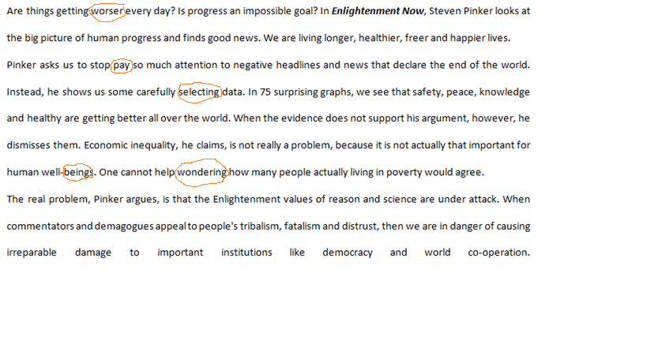

The correct words should have been
- Worse
- Paying
- Selected
- Health
- Being
- Wonder

- Rewrite the following sentences:
6 Points(Each answer is worth 1 point)
- Don’t use this pen.
You don’t use this pen

- They grew the best vegetables.
The best vegetables were grown by them

- He’ll play with his friends. At first, he’ll finish watering the flowers.
Before playing with his friends, he will first water the flowers

- It is a month since I visited them.
I visited them last month

- It is necessary for him to go there.
He has to go there

- You aren’t allowed to park here.
Youcan’t park here
- Read the following scenario and fill in the gaps using the prompts between brackets.
A mysterious letter has arrived for David by special delivery. He is nervous about opening it. Add suitable MODAL VERBS to complete the dialogue. He is with Liza, his wife.
6Points (Each answer is worth 1 point)
Liza: …Can……………………. I have a look at it? (Permission)
David: I …don’t…………………… think who it’s from. (Negative ability)
Liza: It ………may……………… be important. (Assumption)
David: ……………Can……… you read the postmark? (Ability)
Liza: It …………………might……. be from your bank manager (possibility), so you …should………open it immediately. (Advice)

- Complete the sentences. Use adjectives formed by adding –ING or –ED to the words in
brackets.
6 Points (Each answer is worth 1point)
- I find walking in the city very …………disturbing………………. (disturb)
- I don’t normally get …………scared……………. when I watch horror movies. (scare)
- I think learning more than one language is very ………tiring………………. (tire)
- She doesn’t get ………embarrassed………………. easily. (embarrass).
- Jone is ……boring………………… individual. (bore).
- What she said is ……disturbing………….(disturb).

- Do as shown between brackets
6 Points (Each answer is worth 1point)

- I don’t mind (travel) to them. (Correct the verb)
.......traveling...............................................................................................................................................
- I didn’t allow him (go) on his own. (Correct the verb)
........................to go..............................................................................................................................
- (Review) helps us retain information. (Correct the verb)
................................reviewing......................................................................................................................
- This is a 7 days exam. ( Detect & correct the error)
.........................This is a 7-day exam ............................................................................................................
- She did a big mistake.( Detect & correct the error)
..She made a big mistake......................................................................................................................................
- I don’t get offended very easy. ( Detect & correct the error)
..I don’t get offended easily.................................................................................................................................

- Vocabulary(20 Points)
- Give synonymsfor the following vocabulary items.

6 Points (Each answer is worth 1 point)
Vocabulary Item | Synonym
Customer | Client
Barrier | Hurdle
Approximately | Roughly
Limit ( v) | Restraint
Apparently | Evidently
Relocation | Displacement

- Give antonyms for the following vocabulary items.

6Points (Each answer is worth 1 point)
Vocabulary Item | Antonym
Underestimate | Overestimate
Fire (v) | Hire
Accept | Deny
Emotional | Cold
Dismiss | Assemble
Child | Adult

- Add prefixes and suffixes to the following words

8Points(Each answer is worth 1 point)

Prefix | Suffix
Sincere / …insincere…………… | Problem / ……problematic……..
Employment / ………unemployment………… | Assess/ …Assessment……….
Probable /……improbable…………… | Hero/ …Heroism…………
Healthy /………unhealthy……………. | Skill/……Skilful…………..

- Writing& Research (30 Points)
- Open your student book on page 29 and write the four components of knowing a word.
4 Points (Each answer is worth1 point)
- ……………………Meaning…………………………………………………………………………………………………………………………………
- ……………………Spelling…………………………………………………………………………………………………………………………………
- ……………………Pronunciation…………………………………………………………………………………………………………………………
- ……………………Part of Speech…………………………………………………………………………………………………………………………

- Go back to theme 2 page 48 and explain what is meant by the statement ‘… apologizing is culturally determined’’
3 Points
The sincerity in any apology determines the nature of the apology. Therefore, apologizing is dependent on the culture a person is brought up in

- In Britain, people say sorry a lot. How about people in your culture?
3 Points
People in our culture are very respectful. They use the word “please” quite often. The culture is very conservative

- Write an essay of not less than 300 words on the importance of revising for exams.
(Please note that zero is the copying and pastingpenality for this question)
20 Points
As students approach the exams, it is essential to revise. Revision is defined as reading again the concepts learned in class to understand them better in preparation for the exam. Through revision, a student can recall all the topics, figures, and approaches learned throughout the course. Revision helps in increasing the certainty and strength of the content learned. Additionally, once a student revises, he or she will be able to do the exam easily. The first stage in revision is setting a goal on what to revise. A student should allocate adequate time for those topics that were hard to understand in class. Start off by arranging the study space and the materials to be used. The best strategy is to look for an isolated place with minimum distraction. Always ensure that you keep your phones and other devices away in case they will distract you from achieving your desired goals. Once you start revising, give yourself breaks to unwind. The student should place more emphasis on hard topics to ensure mastery of content.
Revision might be difficult for a student if he or she did not understand the concepts in class. Always ensure that you get adequate rest before and after each revision session. If possible, try and revise early in the morning as it promotes better performance. Through revision, a student is able to able to exams tension. A person who has revised is more confident during an exam. Furthermore, when you have revised, you are certain that you will not fail. The student will have everything in control in exam time. As you finish with your revision, you understand the concepts learned and become confident in your mastery of content.
.......................................................................................................................................................................................................................................................................................................................................................................................................................................................................................................................................................................................................................................................................................................................................................................................................................................................................................................................................................................................................................................................................................................................................................................................................................................................................................................................................................................................................................................................................................................................................................................................................................................................................................................................................................................................................................................................................................................................................................................................................................................................................................................................................................................................................................................................................................................................................................................................................................................................................................................................................................................................................................................................................................................................................................................................................................................................................................................................................................................................................................................................................................................................................................................................................................................................................................................................................................................................................................................................................................................................................................................................................................................................................................................................................................................................................................................................................................................................................................................................................................................................................................................................................................................................................................................................................................................................................................................................................................................................................................................................................................................................................................................................................................................................................................................................................................................................................................................................................................................................................................................................................................................................................................................................................................................................................................................................................................................................................................................................................................................................................................................................................................................................................................................................................................................................................................................................................................................................................................................................................................................................................................................................................................................................................................................................................................................................................................................................................................................................................................................................................................................................................................................................................................................................................................................................................................................................................................................................................................................................................................................................................................................................................................................................................................................................................................................................................................................................................................................................................................................................................................................................................................................................................................................................................................................................................................................................................................................................................................................................................................................................................................................................................................................................................................................................................................................................................................................................................................................................................................................................................................................................................................................................................................................................................................................................................................................................................................................................................................................................................................................................................................................................................................................................................................................................................................................................................................................................................................................................................................................................................................................................................................................................................................................................................................................................................................................................................................................................................................................
Relevant Content | Structure & Grammar | Punctuation & Spelling | Transition & Flow
5 | 5 | 5 | 5
Teacher ‘s use only

End of Questions

